**User Guide for Jensen Decors**



|  |  |  |
| --- | --- | --- |
| **SUPERVISOR** | **Miss Samia Mehreen** | |
| **BATCH CODE** | **2501C01** | |
| **GROUP** | **A** | |
| **SERIAL NO** | **ENROLLMENT NUMBER** | **STUDENT NAME** |
| **1** | Student1639612 | Amin ul haq |
| **2** | Student1636429 | MUHAMMAD MAAZ TAHIR |
| **3** | Student1640454 | Shan Saeed |
| **4** | Student1635761 | Rayyan Habib |

**Project Overview:**

**Navbar:**

Using the navbar, the user can navigate through various categories. We have total 7 items in Navbar, which are further classified as:

* HOME
* Shop
* About Us
* Contact Us
* Search icon
* User Icon (for sign up and login)
* Cart icon



**Navbar Menu Catagories And Sub-catagories:**

The navigation bar (navbar) at the top of the website provides users with easy access to all major product categories and their relevant sub-categories. It is sticky at the top of the screen, ensuring it is always visible as users scroll.

Each main category, such as Metal Wall Art, Wallpapers, Mirror Art, and Wall Shelves, is accessible through the main menu. Hovering over these categories reveals dropdown menus with sub-categories making it easier for users to explore specific product types. The menu is fully responsive, adapting to both desktop and mobile views, with a hamburger icon appearing on smaller screens for a collapsible sidebar experience.

This navigation structure ensures that users can quickly and intuitively find the type of wall décor they are looking for without excessive searching or scrolling.

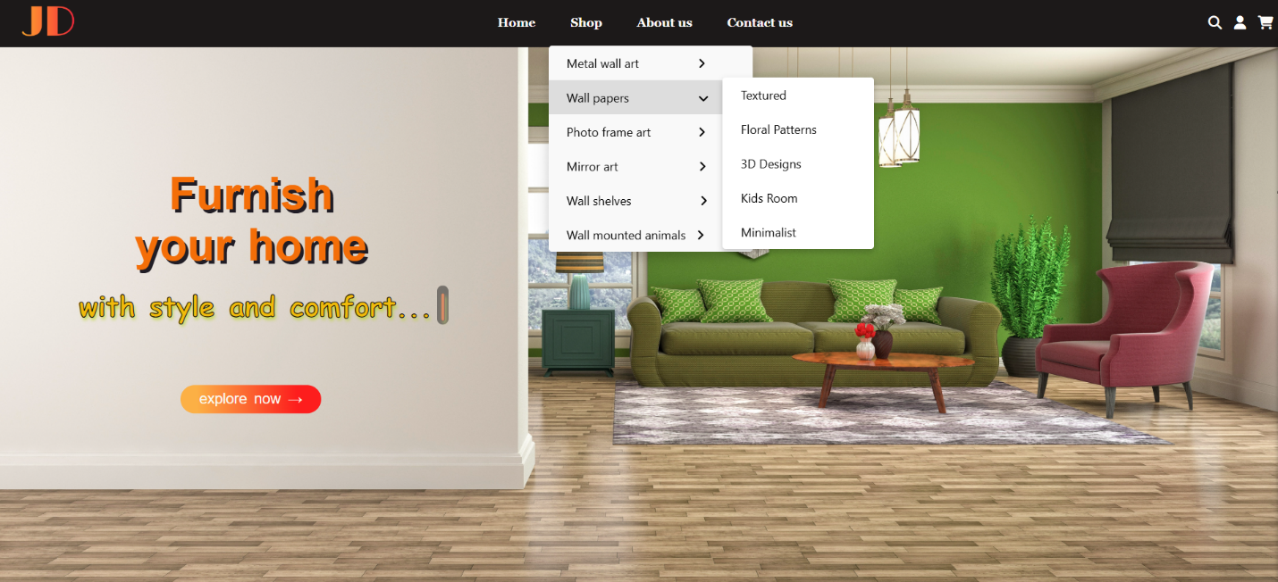

**Add Carousel :**

The homepage features a carousel (image slider) that automatically cycles through high-quality banner images showcasing promotional offers, featured products, or seasonal collections.

This carousel is implemented using Owl Carousel, providing smooth transitions, autoplay functionality, and responsive behavior across all device sizes. Users can also manually navigate between slides using navigation arrows or dots, offering both automation and user control.

The carousel enhances the visual appeal of the website and serves as an effective tool to highlight key products or announcements, encouraging users to explore further.

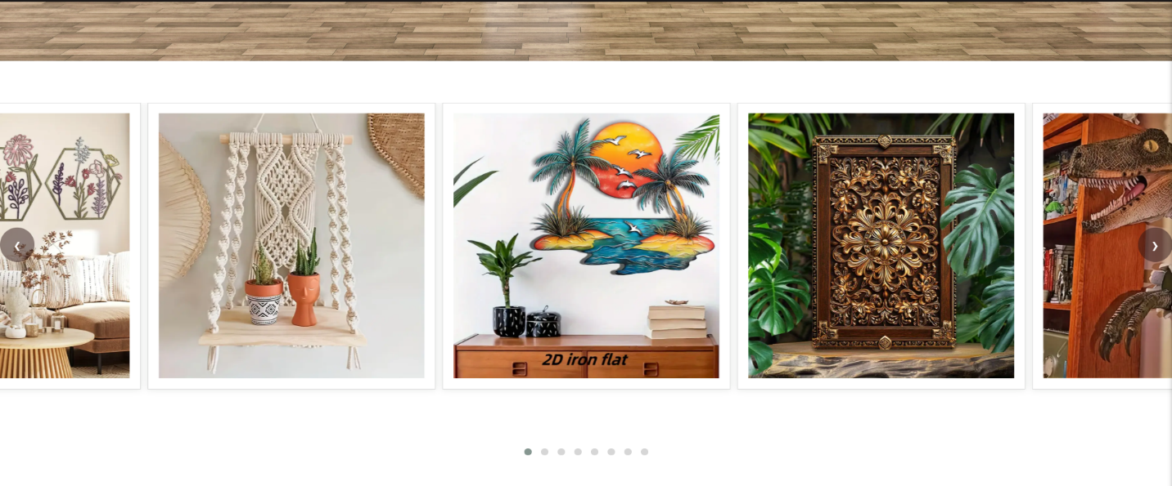

**Adding Some Products from All Categories :**

Each product category (such as Metal Wall Art, Wallpapers, Photo Frame Art, etc.) includes a curated selection of products displayed on the homepage.

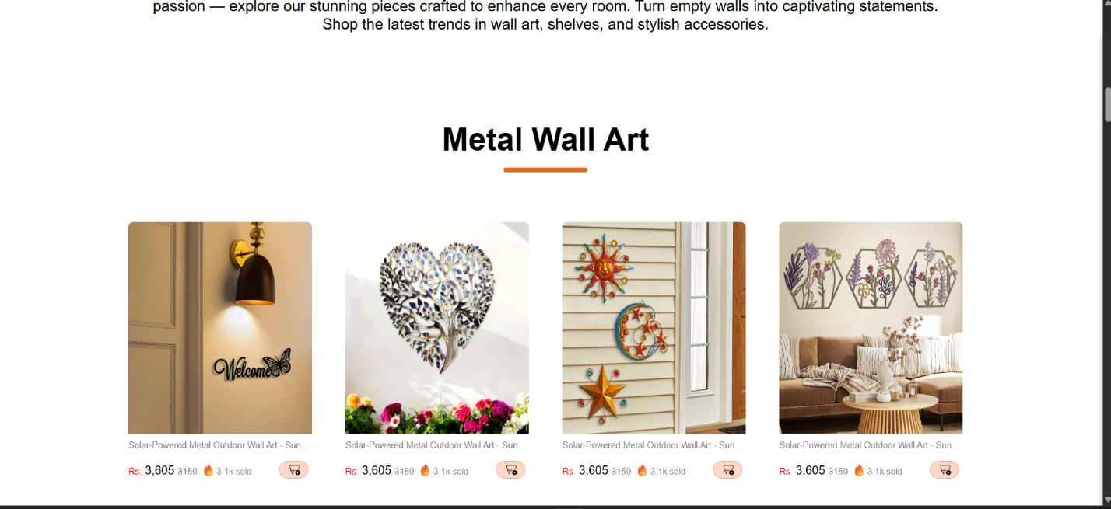

**Testimonials (Customer reviews):**

The Testimonials section displays feedback from customers who have previously purchased products from the website. This section helps build trust and credibility for new users visiting the site.

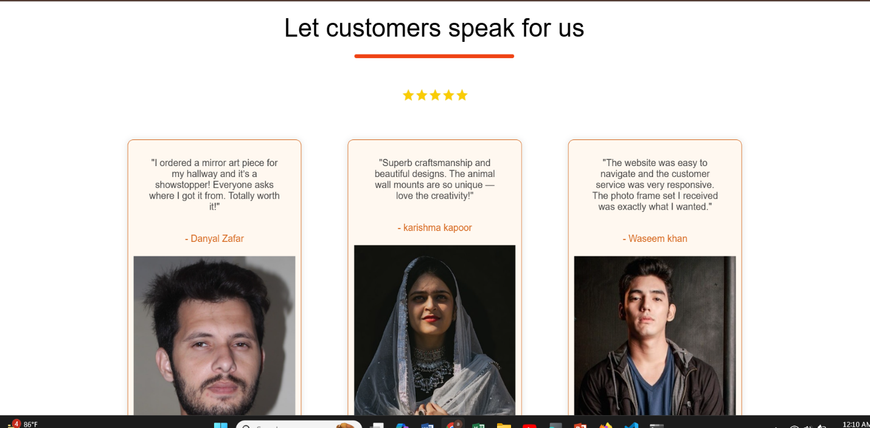

**Footer at the end:**

The Footer is located at the bottom of every webpage and serves as a final point of interaction for users. It contains essential information and quick links that users may find helpful.

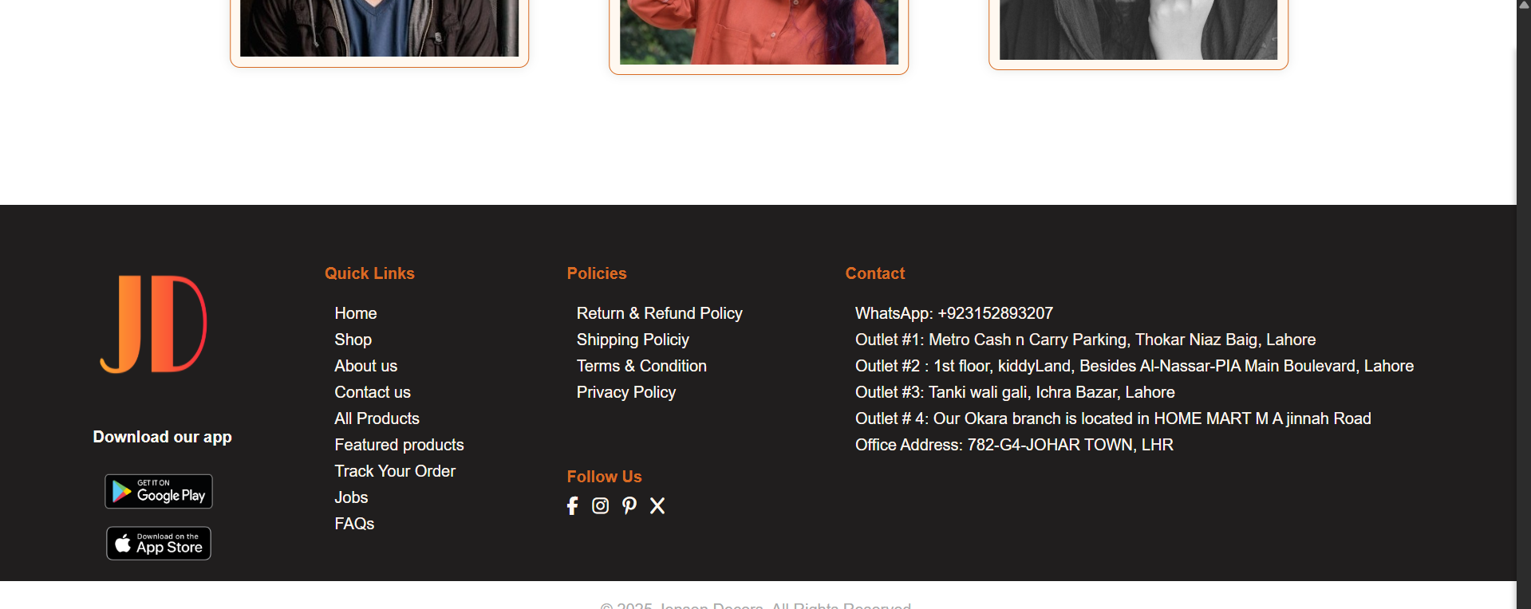

**Individual Categories Page for All Categories:**

Each product category on the website has its own dedicated page, allowing users to explore products more specifically and efficiently.

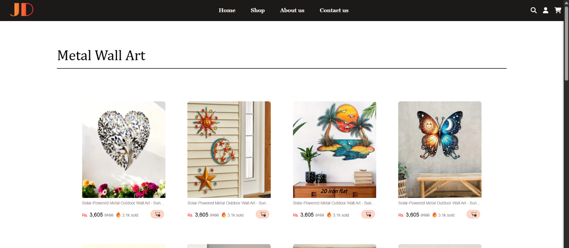

**About Us page:**

The About Us page introduces users to the vision, mission, and story behind Jensen Decors. It helps build trust with visitors by sharing meaningful background information and establishing a personal connection.

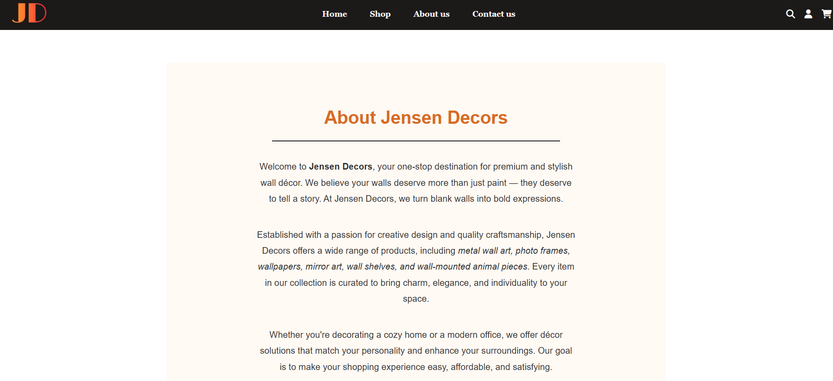

**Contact us page:**

The Contact Us page provides visitors with a simple and accessible way to get in touch with the Jensen Decors team for inquiries, feedback, or support.

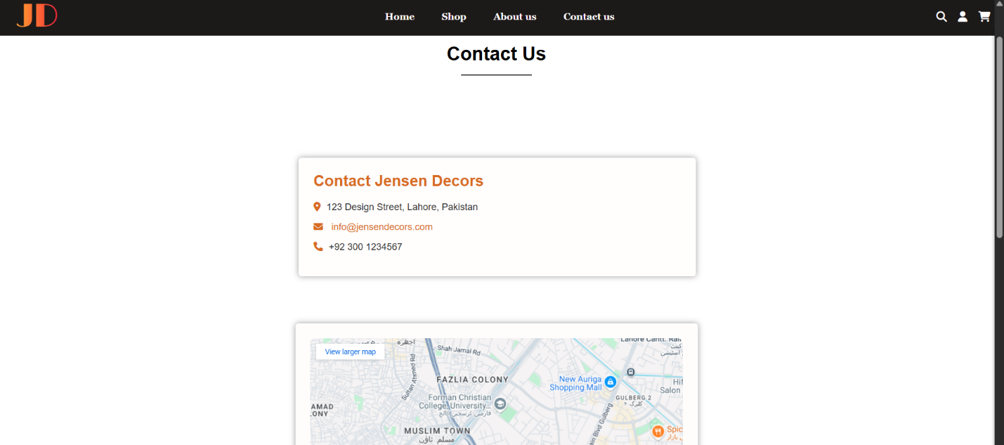

**Sign up or Login page:**

The Sign Up page allows new users to create an account on the website. It is designed to be user-friendly and secure.

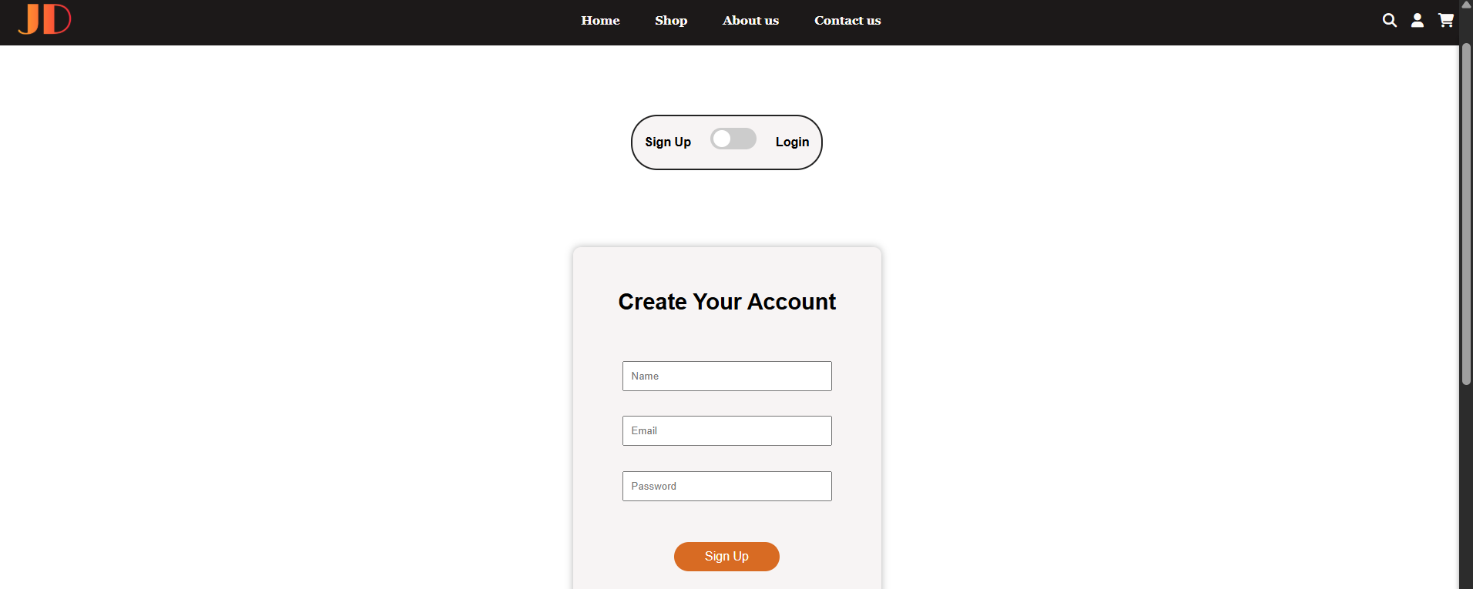

**Product Description Page:**

The Product Description Page is a dedicated section where users can view detailed information about a specific product. It is designed to provide a complete overview of the product's features, helping users make informed purchasing decisions.

